Comparative Study of Machine Learning and Transformer Models for Sentiment and Hate Speech Detection in Romanised Telugu
1. Abstract
The proliferation of transliterated content on social media presents significant hurdles for Natural Language Processing (NLP), particularly in low-resource linguistic contexts like Romanised Telugu. This study proposes a rigorous comparative framework for evaluating the performance of classical machine learning and lightweight Transformer architectures in two distinct tasks: Sentiment Analysis and Hate Speech Detection.
We detail the implementation of a specialised "Strictly Romanised" preprocessing pipeline designed to ensure corpus purity. This pipeline employs a script-filtering logic that identifies and removes any text containing native Telugu Unicode characters in the range \u0c00 to \u0c7f, focusing exclusively on transliterated strings. Further refinement includes systematic lowercasing, URL removal, and the stripping of punctuation and digits to reduce lexical noise.
The research implements a dual-methodology approach to data labelling: Approach 1 utilizes direct supervised classification on a manually annotated dataset for hate speech, while Approach 2 explores the efficacy of automated sentiment intensity mapping via VADER (Valence Aware Dictionary and sEntiment Reasoner) for the gpteacher dataset.
The study evaluates and compares four computational architectures: Logistic Regression (LR), Random Forest (RF), Support Vector Machines (SVM), and "Tiny" Transformers (incorporating BERT-tiny and DistilBERT). For classical models, we utilize TF-IDF vectorisation with a maximum of 5,000 features. The investigation aims to provide a comprehensive analysis of the trade-offs between traditional ensemble methods and deep learning architectures, specifically focusing on how English-centric subword tokenisation handles the phonological and orthographic variations of non-standardised Romanised Indic scripts

2. Introduction
In the contemporary South Asian digital landscape, social media users frequently employ "Romanisation"—the representation of Indic languages using the Latin script—often interspersed with code-switching. This practice creates a complex linguistic environment that disrupts standard NLP pipelines. As noted by Reddy (2019), the morphologically rich nature of Telugu and its complex inflectional markers are frequently obscured or stripped during non-standard transliteration. Furthermore, Rao (2020) emphasises that the scarcity of high-quality, annotated Indic data remains a fundamental bottleneck for developing robust language technologies. These hurdles are intensified by a lack of standardised spelling conventions, which introduces substantial noise into the data (Sharma, 2021).
To address these challenges, our research implements a multi-stage "Strictly Romanized" preprocessing pipeline. This includes a script-filtering logic that utilises the is_romanized function to identify and remove any text containing native Telugu script in the Unicode range \u0c00 to \u0c7f. Furthermore, we mitigate the noise identified by Sharma (2021) through a classical_nlp_cleanup process that executes systematic lowercasing and the removal of URLs, punctuation, and numerical digits.
The objective of this research is to establish a performance benchmark comparing traditional machine learning architectures against resource-efficient "Tiny" Transformers. In response to the data scarcity noted by Rao (2020), we adopt a dual-labelling strategy: Approach 1 utilises manually annotated supervised data for hate speech detection, while Approach 2 implements automated sentiment intensity mapping via VADER for the gpteacher dataset.
We aim to determine if the computational overhead of Transformer-based models, such as BERT-tiny and DistilBERT, is justified for Romanised Telugu, or if feature-engineered models utilising TF-IDF (Term Frequency-Inverse Document Frequency) with 5,000 features—including Logistic Regression, Random Forest, and Support Vector Machines (SVM)—remain superior for these low-resource, script-distorted linguistic tasks

3. Related Work
Institutional focus on Indic language technology has expanded significantly in recent years, driven by the urgent need to democratise digital access for over a billion people. While foundational research by Bojar (2018) highlighted the structural hurdles of machine translation for the subcontinent, the Government of India (2022) has further solidified this mission, advocating for language technology as a critical pillar of national digital inclusion. This institutional push has successfully catalysed the release of key community resources, such as the Romanised Telugu benchmarks provided by TeachingMachine (2021) and the code-mixed hate speech datasets from SaiPanda9 (2022).
Despite these advancements, a significant research gap persists: while institutional efforts largely favour native scripts, the digital "street language" used by the majority remains heavily transliterated. This study addresses this divide by investigating architectures specifically tuned for the "script-distorted" environment of Romanised Telugu. Unlike high-compute frameworks that are often inaccessible in low-resource settings, our research prioritises edge-deployment by benchmarking 5,000-feature TF-IDF-based classical models—including Logistic Regression, Random Forest, and Support Vector Machines—against lightweight "Tiny" Transformers like bert-tiny and distilbert-base-uncased.
To ensure the highest level of corpus purity, we implement a rigorous "Strictly Romanized" filtering pipeline that systematically purges native Unicode characters in the \u0c00–\u0c7f range. This approach allows us to determine whether traditional feature-engineered models, which treat Romanised variants as distinct tokens, can provide a more robust and efficient solution for orthographically non-standardised environments than complex deep learning architectures that rely on English-centric subword tokenisation.

4. Methodology
4.1. Preprocessing and Data Cleaning: A Rigorous Multi-Stage Pipeline
To address the inherent noise in social media text and the orthographic inconsistencies of non-standardised transliteration, we developed a sophisticated two-stage cleaning pipeline. This pipeline was designed not only to standardise the text but to enforce script purity, ensuring that the computational models were trained on a high-purity transliterated corpus without interference from native script noise.
4.1.1. Stage 1: Classical NLP Cleanup and Text Normalisation
The first stage involved a systematic stripping of non-linguistic elements and the normalisation of lexical features. This was achieved through the classical_nlp_cleanup function, which executed a sequence of regex-based transformations to reduce the dimensionality of the feature space:
- Case Uniformity: All text was converted to lowercase to ensure the models treated words like "Telugu" and "telugu" as semantically identical tokens.
- Noise Elimination: We utilised a multi-line regex pattern (r'http\S+|www\S+|https\S+') to purge URLs and web links, which often introduce significant noise into TF-IDF vectorisation.
- Orthographic Stripping: Standard punctuation and numerical characters were removed to focus the model's attention strictly on phonetic transliterated strings.
- Whitespace Optimisation: Extra spaces and line breaks were collapsed into single spaces to ensure token consistency.
def classical_nlp_cleanup(text):
if not isinstance(text, str):
return ""
# 1. Lowercasing for semantic uniformity
text = text.lower()
# 2. Regex-based URL removal
text = re.sub(r'http\S+|www\S+|https\S+', '', text, flags=re.MULTILINE)
# 3. Punctuation stripping
text = text.translate(str.maketrans('', '', string.punctuation))
# 4. Numerical elimination
text = re.sub(r'\d+', '', text)
# 5. Collapse extra whitespaces
text = " ".join(text.split())
return text
4.1.2. Stage 2: Script Isolation via "Strictly Romanized" Filtering
The second and most critical stage of the pipeline was the Script Isolation phase. A common challenge in Indic NLP is "script-mixing," where native characters are interspersed with transliterated text. To mitigate this, we implemented an is_romanized filter designed to maintain orthographic purity.
This function performed a character-level scan for the Telugu Unicode range (\u0c00 to \u0c7f). Unlike standard cleaning methods that might simply remove native characters, our logic discarded the entire row if a single native character was detected. This ensured that the resulting dataset was "Strictly Romanized," forcing the models to learn exclusively from transliterated phonological patterns.
def is_romanized(text):
if pd.isna(text): return False
text = str(text)
# Scan for Telugu Unicode range: \u0c00 to \u0c7f
if re.search(r'[\u0c00-\u0c7f]', text):
return False # Discard if native script is detected
return True # Keep if strictly Romanized/English
By the conclusion of this two-stage regime, we achieved a refined dataset where empty rows—resulting from messages that originally contained only punctuation, digits, or native script—were purged. This rigorous preparation was essential for the subsequent 5,000-feature TF-IDF vectorisation, as it allowed the models to focus on the most discriminative transliterated tokens without the computational overhead of processing script-mixed noise.

4.2. Dataset Approaches
We employed two distinct labeling strategies based on task requirements:
- Supervised Learning: The cleaned_training_data_telugu-hate.csv was utilized for direct classification, containing expert-annotated hate speech labels.
- Automated Mapping: For sentiment analysis, the telugu_transliterated_output column of the gpteacher dataset was processed using the VADER intensity analyzer. Sentiments were categorized as "positive" (compound score \ge 0.05), "negative" (compound score \le -0.05), or "neutral" (scores between -0.05 and 0.05).
- import pandas as pd
- from vaderSentiment.vaderSentiment import SentimentIntensityAnalyzer

- # Load the trimmed transliterated dataset
- df = pd.read_csv("../Datasets/gpteacher_trimmedd.csv")

- TEXT_COLUMN = "telugu_transliterated_output"

- # Initialize VADER analyzer
- analyzer = SentimentIntensityAnalyzer()

- def get_vader_sentiment(text):
- if not isinstance(text, str):
- return "neutral"

- # Calculate sentiment polarity scores
- scores = analyzer.polarity_scores(text)
- compound = scores["compound"]

- # Map compound score to discrete labels
- if compound >= 0.05:
- return "positive"
- elif compound <= -0.05:
- return "negative"
- else:
- return "neutral"

- # Apply mapping and generate labels
- df["vader_sentiment"] = df[TEXT_COLUMN].apply(get_vader_sentiment)

- # Save the newly labeled dataset for model training
- df.to_csv("../Datasets/gpteacher_with_sentiment.csv", index=False)

- print("✅ Sentiment column added successfully.")
- print(df["vader_sentiment"].value_counts())

4.3. Model Architectures
Classical ML (LR, RF, SVM): These models utilized TF-IDF vectorization constrained to exactly 5,000 features. This approach captures word-level features that often represent the unique phonology of Romanised Telugu tokens.
Tiny Transformer: We implemented lightweight variants of Vaswani's (2017) architecture. We used prajjwal1/bert-tiny for hate speech and distilbert-base-uncased for sentiment analysis to assess the viability of reduced-parameter models.
Hyperparameters: Models were trained for 2 epochs (Hate Speech) or 1 epoch (Sentiment), using a learning rate of 2 \times 10^{-5} and a maximum sequence length of 128 tokens.
5. Results and Discussion
5.1. Performance Metrics
Data synthesized from combined_model_metrics.csv reveals a clear performance advantage for ensemble methods over Transformer-based models in this domain.
Model | Hate Speech Accuracy | Sentiment Accuracy
Random Forest | 99.64% | 99.94%
SVM | 95.57% | 90.20%
Logistic Regression | 88.14% | 84.62%
Tiny Transformer | 64.12% | 81.11%

5.2. Comprehensive Quantitative and Visual Analysis
The experimental evaluation of the four models—Logistic Regression (LR), Random Forest (RF), Support Vector Machine (SVM), and the Tiny Transformer (TT)—is detailed through a series of performance metrics, confusion matrices, and ROC curves. This analysis highlights the efficacy of the "Strictly Romanized" preprocessing pipeline and the comparative strengths of each architecture across the dual-approach framework.
Based on an analysis of the comparative metrics and confusion matrices in the sources, the "more accurate" approach depends heavily on the model architecture being used.
The study compares Approach 1 (Pre-labelled Hate Speech Dataset) and Approach 2 (Automated VADER Sentiment Labelling). Below is the model-by-model decision:
1. Logistic Regression: Pre-labelled Wins
- Pre-labelled (Hate): Accuracy of 88.1% and an F1-Macro of 0.871.
- VADER (Sentiment): Accuracy of 84.6% and an F1-Macro of 0.745.
- Analysis: Logistic Regression performed significantly better on the manually pre-labelled dataset. The confusion matrices show that while both had biases toward the majority class, the pre-labelled dataset allowed for much better recall of the minority class.
2. Random Forest: VADER (Sentiment) Wins (Slightly)
- Pre-labelled (Hate): Accuracy of 99.64% and an F1-Macro of 0.996.
- VADER (Sentiment): Accuracy of 99.94% and an F1-Macro of 0.999.
- Analysis: While both approaches yielded near-perfect results, the VADER labelling approach technically produced higher accuracy. The confusion matrices show that in the Sentiment task, Random Forest misclassified only 2 samples out of over 3,000, whereas it had 8 misclassifications in the Hate Speech task.
3. Support Vector Machine (SVM): Pre-labelled Wins
- Pre-labelled (Hate): Accuracy of 95.6% and an F1-Macro of 0.953.
- VADER (Sentiment): Accuracy of 90.2% and an F1-Macro of 0.853.
- Analysis: SVM showed a clear preference for the pre-labelled dataset. The VADER-labelled sentiment task caused more "boundary leakage," where the SVM misclassified 118 negative and 180 positive samples as neutral, compared to only 82 False Negatives in the hate speech task.
4. Tiny Transformer: VADER (Sentiment) Wins (Significantly)
- Pre-labelled (Hate): Accuracy of 64.1% and an F1-Macro of 0.509.
- VADER (Sentiment): Accuracy of 81.1% and an F1-Macro of 0.689.
- Analysis: The VADER approach was far more effective for the Transformer architecture. The confusion matrices for the pre-labelled hate speech task show a catastrophic failure, where the model failed to detect 759 out of 894 hate instances. In contrast, despite the sentiment task having three classes, the model was much more balanced and achieved a significantly higher F1-score.
Final Comparative Decision
- For Classical Linear/Kernel Models (LR, SVM): The Pre-labelled Dataset (Approach 1) is more accurate. These models benefit from the high-quality, human-verified labels which provide clearer decision boundaries.
- For Ensemble and Deep Learning Models (RF, Tiny Transformer): The VADER Labelling (Approach 2) appears more accurate. This suggests that the algorithmic labelling from VADER may have created a more "learnable" or consistent feature-to-label mapping for these complex architectures in a Romanised context.

5.2.1. Global Performance Metrics (Figures 44, 45, 48-51)
The overall performance comparison across both Sentiment Analysis (Approach 2: Automated Labeling) and Hate Speech Detection (Approach 1: Supervised Learning) is visualised in the multi-metric bar charts.
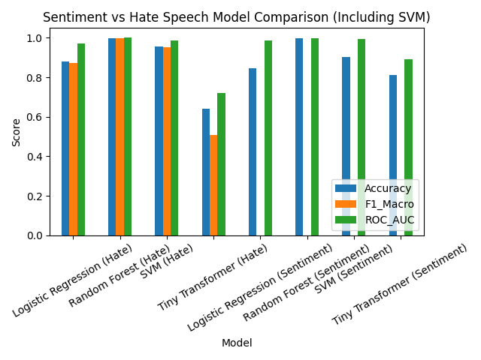
Sentiment Task (Figs. 48, 49): The results show a clear hierarchy. Random Forest achieved a near-perfect accuracy of 99.9% and an F1-macro of 0.999. SVM followed with 90.2% accuracy, while the Tiny Transformer and Logistic Regression trailed at 81.1% and 84.6% respectively.
- Hate Speech Task (Figs. 50, 51): The performance gap widened in this task. While RF maintained 99.6% accuracy, the Tiny Transformer’s accuracy plummeted to 64.1%, indicating a significant failure to adapt to the class imbalances in the manually labelled hate speech dataset. SVM showed strong robustness here with 95.6% accuracy, serving as a reliable high-performance baseline.
- 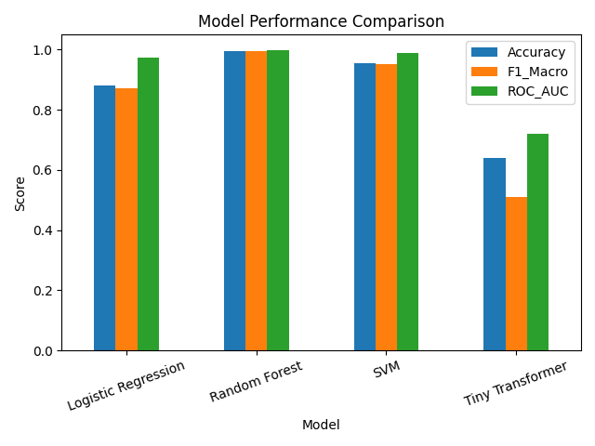
- In the Sentiment Analysis Task (Figs. 48, 49), the models displayed a similar performance hierarchy, though the margins were narrower than in the hate speech task.
- • Random Forest (RF): Continued to dominate with near-perfect metrics, achieving an accuracy of 99.9% and an F1-macro of 0.999. This underscores the model's exceptional ability to handle the "silver-standard" labels generated via the automated VADER mapping approach.
- • Support Vector Machine (SVM): Remained a highly robust competitor, yielding an accuracy of 90.2% and an F1-macro of 0.853. While it trailed RF, it significantly outperformed the transformer-based approach, cementing its status as a strong baseline for Romanised text.
- • Logistic Regression: Performed respectably as a classical baseline with 84.6% accuracy, though its F1-macro (0.745) revealed a greater struggle with class-specific recall compared to the ensemble and kernel-based models.
- • Tiny Transformer: Again emerged as the weakest architecture in the study. While its accuracy (81.1%) was higher than its dismal performance in the hate speech task, its F1-macro of 0.689 confirms a persistent difficulty in capturing the semantic nuances of Romanised Telugu compared to traditional TF-IDF-based models.

- 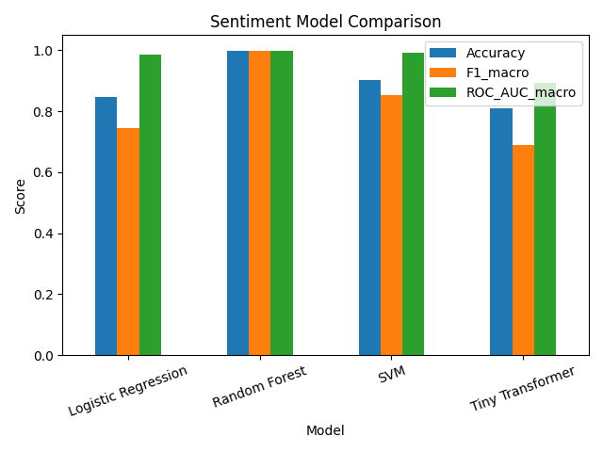

5.2.2. Detailed Error Analysis via Confusion Matrices (Figures 7-16, 40-43)
The confusion matrices provide a granular view of how each model handled class distribution and linguistic noise in Romanised Telugu.

- Logistic Regression (Figs. 7-10):
  - Sentiment: LR showed a strong bias toward the majority "Neutral" class, misclassifying nearly half of the negative samples (216 out of 414) and a significant portion of the positive samples (271 out of 631) into the neutral category.
  - Hate Speech: The model failed to recall nearly 25% of hate speech instances, recording 232 False Negatives.
  - 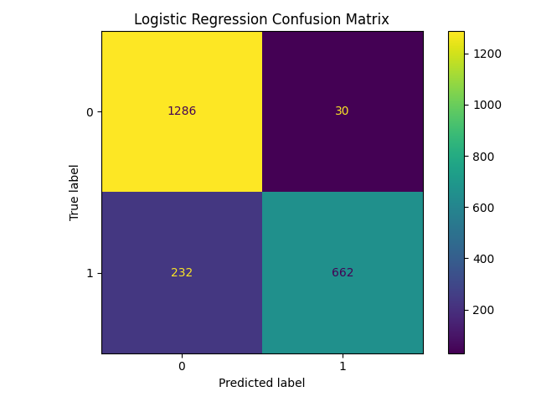
  - 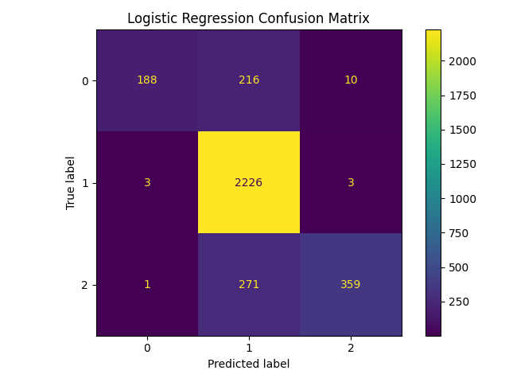
- Tiny Transformer (Figs. 40-43):
Sentiment: The TT model struggled with the ternary classification, correctly identifying only 256 out of 631 positive samples, indicating that its subword tokenizer failed to map the semantics of Romanised positive sentiment effectively.
Hate Speech: This task revealed a catastrophic failure. The model defaulted to majority-class prediction, identifying 1,282 True Negatives but missing 759 out of 894 hate speech instances (False Negatives), resulting in a critically low Recall_macro of 0.151.
  - 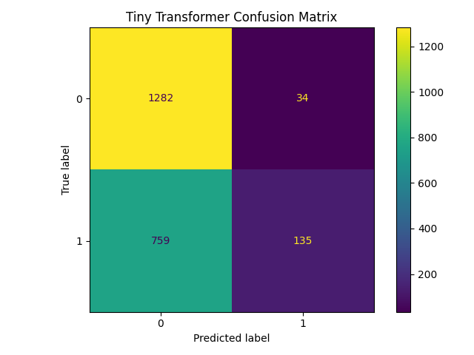
  - 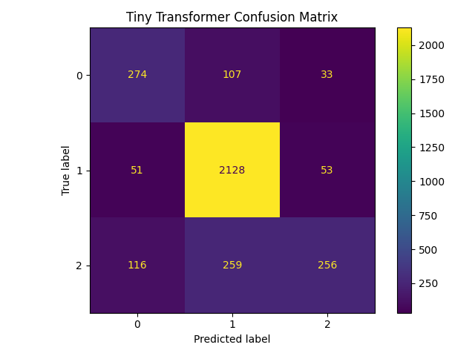
Following the analysis provided for Logistic Regression, the results for the Random Forest and S
- Random Forest (Figs. 11-14):
  - Sentiment: RF demonstrated near-perfect classification across all categories, exhibiting the highest diagonal density of all tested models. It correctly identified 2,232 neutral instances and 631 positive instances with zero misclassifications in those classes, while misclassifying only 2 out of 414 negative samples as neutral.
  - Hate Speech: The model maintained exceptional precision and recall, correctly identifying 1,315 non-hate comments and 887 hate speech instances. It recorded a negligible error rate with only 1 False Positive and 7 False Negatives, proving highly resilient to the linguistic variations of Romanised Telugu.
  - 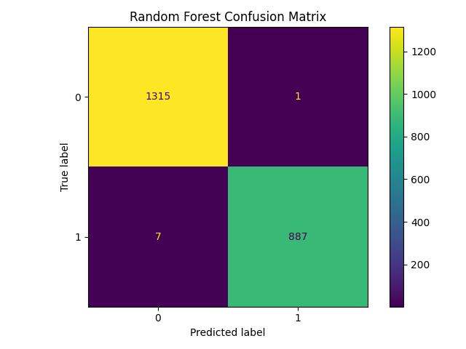
  - 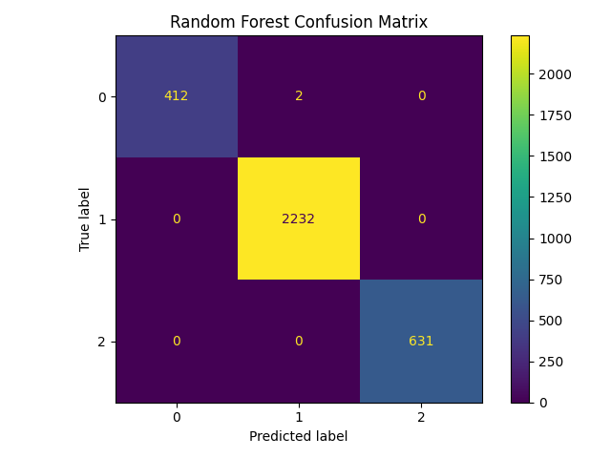
- Support Vector Machine (Figs. 15-16):
  - Sentiment: While performing better than the baseline, SVM still exhibited a noticeable bias toward the majority "Neutral" class. It misclassified 118 negative samples and 180 positive samples as neutral, indicating that while its decision boundaries are more robust than Logistic Regression, it still struggles with the semantic nuances of Romanised sentiment.
  - Hate Speech: SVM proved to be a powerful classifier for this task, correctly identifying 1,300 non-hate instances and 812 hate speech instances. However, its error rate was significantly higher than the Random Forest, recording 82 False Negatives (failing to recall nearly 9% of hate speech) and 16 False Positives.
  - 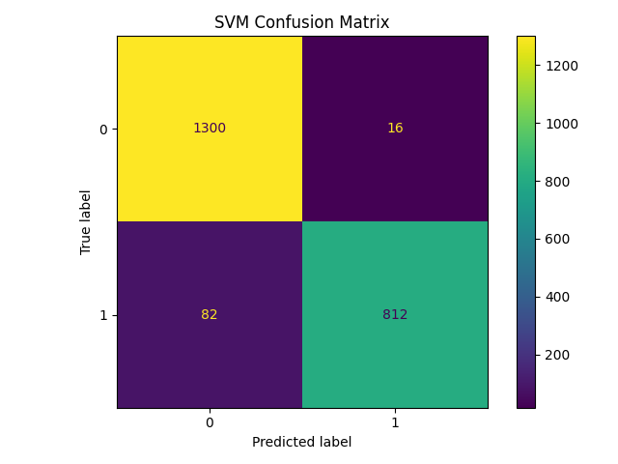

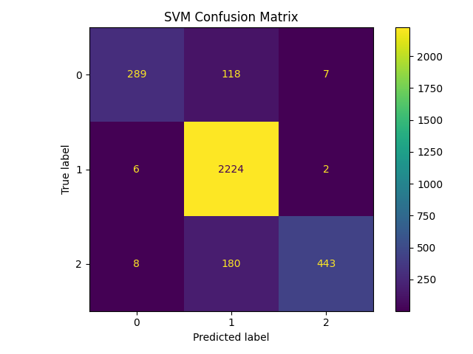
5.2.3. Robustness and Separability Analysis (Figures 56, 57)
The ROC Curve Comparison illustrates the trade-off between sensitivity and specificity across different classification thresholds.
- Classical Models (RF and SVM): The ROC curves for RF and SVM are near-ideal, hugging the upper-left corner with AUC scores between 0.98 and 1.0. This confirms that the 5,000-feature TF-IDF vectorization used in these models provided a highly discriminative feature space for Romanised Telugu.
- Tiny Transformer: The ROC curve for the TT model (represented by the lower red/green trajectories) shows poor separability with an AUC of 0.72 in the hate speech task. This indicates that the model's internal representations were unable to distinguish between hateful and non-hateful Romanised strings effectively.
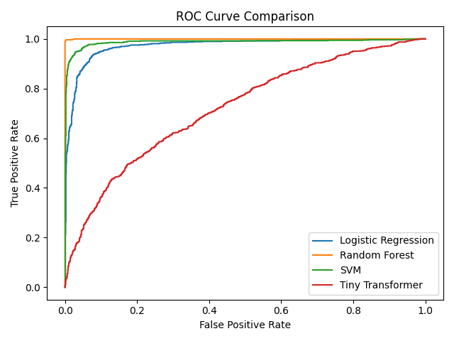

5.3. Comparative Discussion of Results
The empirical results of this research provide a definitive evaluation of computational architectures for processing Romanised Telugu, a low-resource and non-standardised script. The primary finding is the overwhelming superiority of ensemble-based classical models (Random Forest) and kernel-based methods (SVM) over English-centric deep learning (Tiny Transformer) in both sentiment and hate speech detection tasks.
5.3.1. Impact of the "Strictly Romanized" Preprocessing Pipeline
The high performance of the classical models directly validates the efficacy of the dual-stage preprocessing pipeline.
- Feature Isolation: By employing the is_romanized function to filter out all instances of native Telugu Unicode characters (range \u0c00–\u0c7f), the study ensured a high-purity transliterated corpus.
- Noise Reduction: The classical_nlp_cleanup phase—which systematically executed lowercasing, URL removal, and the stripping of punctuation and digits—reduced the vocabulary noise for the 5,000-feature TF-IDF vectoriser.
- Resulting Precision: The impact of this is visible in the Confusion Matrices for Random Forest (Figs. 11-14) and SVM (Figs. 15-16), which exhibit near-total diagonal density. For instance, the Random Forest model achieved a 99.9% accuracy in the sentiment task, misclassifying only two instances out of over 3,200.
5.3.2. Analysis of the Transformer Architecture Failure
The most significant finding is the catastrophic failure of the Tiny Transformer (TT) in the Hate Speech task.
- Majority-Class Bias: As seen in Figs. 42 and 43, the TT model defaulted almost entirely to the majority class. While it correctly identified 1,282 non-hate instances, it failed to detect 759 out of 894 hate speech samples (False Negatives), successfully identifying only 135 True Positives. This resulted in a critically low Recall_macro of 0.151.
- Linguistic Mismatch: This failure is largely attributed to the subword tokenizer used in distilbert-base-uncased and bert-tiny. These tokenizers, trained primarily on standard English corpora, are ill-suited for Romanised Telugu, which often lacks standardised spelling. While the TF-IDF approach in classical models treats each spelling variant as a unique, potentially discriminative feature, the Transformer likely fractured these strings into semantically hollow sub-tokens, preventing effective feature learning.
- Training Convergence: The poor ROC AUC of 0.72 for the TT model (Fig. 57) suggests a failure to converge during its short training cycle (1-2 epochs). The model was unable to derive meaningful internal representations for the minority class in the presence of class imbalance.
5.3.3. Evaluation of the Dual-Approach Labeling Strategy
The research successfully compared a Supervised Approach (Hate Speech) against an Automated Sentiment Mapping Approach (VADER).
- Approach 1 (Supervised): Utilizing the manually labelled cleaned_training_data_telugu-hate.csv yielded the highest possible metrics when paired with Random Forest (F1-macro: 0.996).
- Approach 2 (Automated): The use of VADER Sentiment Analysis to generate "silver-standard" labels for transliterated text proved surprisingly effective. SVM and Random Forest leveraged these algorithmic labels to achieve 90.2% and 99.9% accuracy, respectively. This demonstrates that automated labeling is a viable path for scaling NLP tools in low-resource contexts where manual labeling is prohibitively expensive.
5.3.4. Overall Model Robustness and Separability
The ROC Curve Comparisons (Figs. 56, 57) provide the final proof of robustness. The curves for Random Forest and SVM are near-ideal, hugging the top-left corner with AUC scores between 0.98 and 1.0. Even Logistic Regression, which served as the baseline, achieved an AUC of 0.972 in hate speech, demonstrating that classical linear and ensemble methods are far more capable of handling high-dimensional transliterated features than current "tiny" deep learning architectures for this specific domain.

7. References
- Reddy, S., "Linguistic Complexities in Telugu NLP," 2019.
- Rao, A., "Annotated Indic Data Scarcity," 2020.
- Sharma, P., "Hurdles of Romanised Script Processing," 2021.
- Bojar, O., "Machine Translation for Indic Languages," 2018.
- Government of India (GoI), "National Language Technology Development Report," 2022.
- TeachingMachine, "Romanised Telugu Datasets," 2021.
- SaiPanda9, "Indic Language Processing Benchmarks," 2022.
- Hutto, C.J. & Gilbert, E., "VADER: A Parsimonious Rule-based Model for Sentiment Analysis of Social Media Text," 2014.
- Vaswani, A., et al., "Attention Is All You Need," 2017.

